Başkent University
Department of Electrical and Electronics Engineering
EEM 311 Electronics II

Experiment V

CMOS Common-Source AmplIfIer wIth an actIve load

Aim:

The aim of this experiment is to analyze the CMOS common-source (CS) amplifier with an active load.

Theory:

The basic amplifier transistor is still the NMOS. However a current source has been replaced the load resistor R_{D}, as schematically shown in Fig.1(a). We call this an active load. The advantage of doing so is:

(1) larger resistor (i.e. the output resistance r_{o}) and thus a larger amplification;
(2) no need to use a resistor. The latter is of particular importance for integrated circuits where large resistors are hard to make and occupy a large area.

The resistor R_{G} sets the gate voltage V_{G} and is kept very large in order not to load the input source. A current source can be implemented with a PMOS current mirror as shown in Fig.1(b).

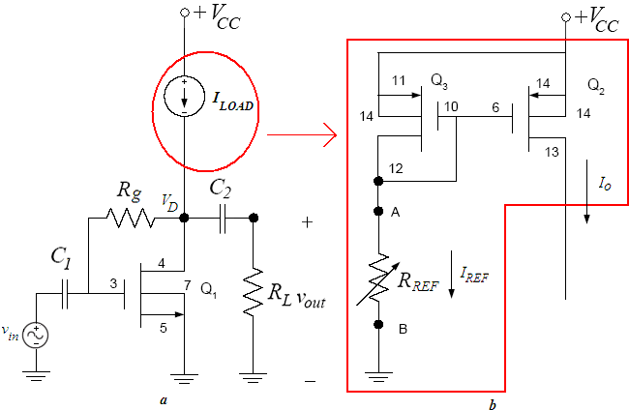
figure1
By replacing the current source by the current mirror, we obtain the complete amplifier with active load as shown in Fig.2. We have also added a load resistor R_{L} and a coupling capacitor C₂.
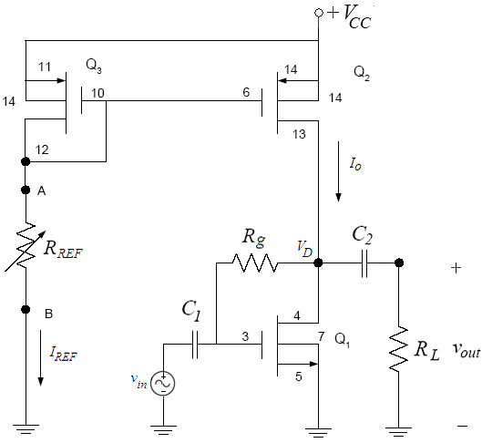
figure2

Preliminary Work:

In laboratory you will construct the circuit in Fig.2 using the MOSFET Chip CD4007 and following values ;

V_{CC} | R_{L} | R_{g} | C₁ | C₂
15 V | 100kΩ | 1 MΩ | 10μF | 10μF

The NMOS has μ_{o}C_{ox}= 166.67μA/V², W/L=3 and V_{T} = 1.45V. Assume V_{A} =1/λ =100V. The PMOS has μ_{o}C_{ox}= 166.67μA/V², W/L=3 and V_{T} = -1.3V. Assume V_{A} =1/λ =100V. (You can download data sheet CD4007C.pdf from course web page). The Pin Diagram of the CD4007 Chip is in Fig.3.

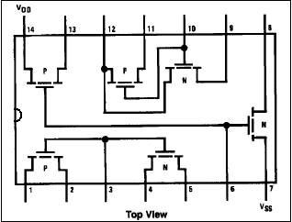
Reference:

[1] The values given for the μ_{o}C_{ox}(W/L) and V_{T} found using the measured data on the CD4007 chip were provided courtesy of Dr. David M. Binkley, Associate Professor at the University of North Carolina at Charlotte and Clark Hopper M.S, R.A. and Harold Hearne M.S., R. A. both also at the University of North Carolina at Charlotte.

figure3

- Find the value of R_{REF}, so that the DC value of I_{REF} is 0.6mA.

- Find the Q point of the NMOS transistor (I_{D} and V_{DS}) and its operation region.

- Draw the small signal AC equivalent of the circuit in Fig.2.

- Derive the overall voltage gain equation A_{v}=v_{out}/v_{in} for the CS amplifier shown in Fig. 2 and find the value of overall voltage gain.(Show all your work clearly)

- Find the input impedance R_{in}.

- Simulate the current mirror using PSPICE. You will need to use a model for the CD4007 transistor. The models can be found in the CD4007.LIB library.

  - Construct your circuit in Fig.2 in Pspice.(***MΩ=MegΩ in Pspice***)

  - Bias simulation. Simulate the circuit of Fig.1. Do a BIAS simulation and find the reference current I_{REF}, output current I_{o} and the DC voltages(V_{D}, V_{G,} ), current I_{D} of the NMOS transistor. Compare the results with the one you calculated in preliminary work.

  - Next, do a Transient simulation. Use as input signal a sinusoidal source (VSIN) of 5 kHz frequency and amplitude of 50mV Peak-to-Peak. Find the input and output voltage. What is the voltage gain? Compare the simulation results with your hand calculations.
  - Replace and emulate the resistor R_{REF} with a NMOS transistor, Q4 between points A and B in Fig.2. Do the step b. and c. again.

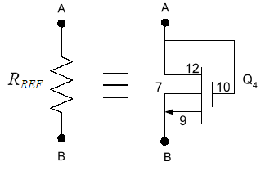
figure3

  - What are the consequences of replacing and emulating R_{REF} with the NMOS transistor shown in Figs. 2 and 4?

  - Summarize the simulation results in table in table form and hand it in together with the calculations and the simulation print-outs. Label each graph clearly

Experimental Work:

You will be using the CD4007 MOSFET array as in this lab. This array contains three NMOS and three PMOS transistors as shown in Fig.5. Again, the key point to remember is that the bulk (or substrates) of all NMOS transistors are connected to the VSS (pin 7) and all PMOS substrates are connected to VDD (pin 14). When using this array pin 7 should be connected to the most negative supply voltage or to the source of the transistor. Pin 14 is the substrate of the PMOS and must be connected to the most positive supply voltage in the circuit!
The CD4007 MOSFET array should not be connected to circuits with the power on because high transient voltages may cause permanent damage. Therefore, do not apply input signals until you have connected PIN 7 and 14; otherwise, serious damage to the device could result.
It should be mentioned that the transistor characteristics of the CD4007 could vary considerably from chip to chip. The transistors may come from a different batch, what can explain why the threshold voltage, the transconductance parameter and the output resistance is different from the one used in the hand calculations and Spice simulation.
Precaution: MOSFET transistors are very susceptible to breakdown due to electrostatic discharge. It is recommended that you always ground yourself before picking up the MOSFET chip. Do no touch any of the pins of the chip.
Note: Use jumper wires as possible as short on your board to connect the pins of the transistors.

Before constructing the circuit,

- Verify the values of the resistors that you are going to use by measuring their resistances with a multimeter. Make sure that all resistors are within 2% of their marked values. This will assure that your current measurements are accurate

- Prepare the power supply for V_{CC} to ensure a DC voltage of 15V and adjust the function generator for v_{in} to a voltage level of approximately 50mV Peak to Peak at a frequency of 5kHz.

Construct the amplifier circuit in Fig.2 using the values for the resistors R_{G} calculated in the preliminary work section and the values indicated in the preliminary work section.
Note: Always turn on the DC power supply before applying the AC signal. Always turn off the AC signal before turning off the DC power supply.

- Adjust the potentiometer R_{REF} so that I_{REF} is around 0.6mA. After adjusting R_{REF}, record R_{REF}. What is the corresponding output current(drain current of the NMOS) I_{O}? Measure and record DC voltages V_{A} and V_{G}, V_{D} of NMOS transistor and compare these with your calculations. Compare these values with those calculated in the Preliminary work.

I_{O} = I_{D} =
R_{REF} =
V_{A} =
V_{G} =
V_{D} =
- Measure the voltage gain of your amplifier: Observe the input and output voltage waveforms on the oscilloscope. Are the input and output waveforms out of phase? Explain. Calculate the voltage gain of the amplifier and compare with your calculations

v_{in} v_{out}


A_{v} =

- Measure the input impedance R_{in} using method at the experiment3.(R_{x}=100kPOT)

R_{in} =

- Discuss the advantages of having an active load over a resistive load in the CS amplifier?

Experiment Instruments:  - Breadboard  - Oscilloscope  - Signal Generator  - Multimeter  - DC Power Source | Experiment Components:  1 CD4007  1 1MΩ  1 100kΩ  1 50k POT  1 100k POT  2 10 μF

...............................………………………………………………………………..

Experiment Results

Part1 | I_{O} = I_{D} =  R_{REF} =  V_{A} =  V_{G} =  V_{D} =
Part2 | A_{v} =
Part3 | R_{in}=

Student Name :

Signature…………….………….

